Chicago Dance Marathon Article
Author: Kennedy Higginbottom.

Purpose

The Lurie Children's Foundation has a purpose of raising money for children who are in their hospital that go through intensive care. In an effort to support the Lurie Foundation, the CHICAGO Dance Marathon is an inspirational event in which people dance or stand within the team for 8 hours to raise much-needed funds for the patients of Ann & Robert H. Lurie Children’s Hospital of Chicago. Whitney Young has a Chicago Dance Marathon club that participates each spring in the event. By joining the club, you’ll be entertained and inspired as more than 20 patient families cheer you on and share their amazing stories at the CHICAGO Dance Marathon.
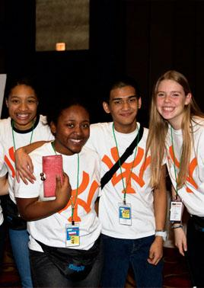

What Fundraising Effort Will Buy The Children

Kyra McGee WY ‘18 (second from left in the picture above) is a Club member who thinks the event is well worth participating in. “I have been a part of this club for three years and every year I enjoy the event and fundraising.”

How to be a part of this Journey?
- Join
- Raise at least $500
- Go to Dance Marathon
- Celebrate
How to Join the Team at Whitney Young?
- Come to a club meeting
- Pay the $35 registration fee
- Come to weekly meetings
- Raise money
- Have Fun!

