Safety in the Streets
By Kennedy Higginbottom
With homecoming season approaching, we should remind ourselves of some safety requirements when driving.
Seat belts-
- -Protect people by putting restrictions on their bodies’
- -Reduce the amount of injuries in car accidents
- -Should be worn by all car passengers, including the drivers
- -If not worn there could be fine starting 25$- and for children $75 for the first offense, $200 for the second offense.
Proper way to wear seatbelt-
- Should be worn across a person’s shoulder and across their upper thigh/lap.
- Should not be worn to the point that it will strain the neck and prevent breathing.
- Should be worn around your hip and make sure it is not too tight but tight enough so you won’t slip out.
Airbags-
Airbags are safety devices made of nylon within a vehicle that expands in order to work along with seat belts to protect drivers and passengers during a vehicle collision.
How does it work?
With force equivalent to going ten to fifteen miles at a brick wall the sensor within the airbags will activate and release nitrogen into the airbags. Within one twenty fifth of a second the airbag will expand.
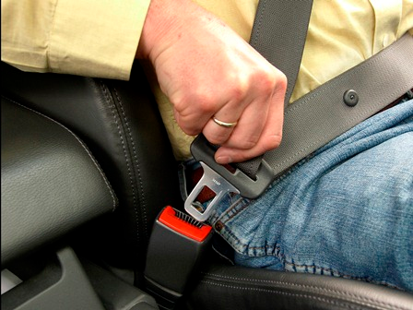
A concerned high school parents states “Teens need to be caution because many of them are new drivers and don’t drive as well as they believe they can”.

